ABOUT THE LECTURER:

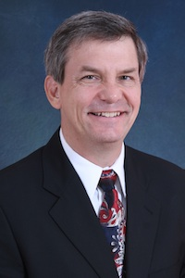
Rev Dr Rick Griffith

Rev Dr Rick Griffith is an Associate Professor of Biblical Studies and also a Doctor of Ministry (DMin) Director at Singapore Bible College, where he has taught Bible, theology and preaching since 1991. He also helped start the K-12 International Community School and Crossroads International Church. He also trains pastors in Mongolia, Sri Lanka, Nepal, Myanmar and restricted nations.

Dr Rick and his wife Susan are missionaries with WorldVenture. Their sons are Kurt (28), Stephen (25) and John (22).

COURSE DESCRIPTION

A general overview of the message of each Old Testament historical book, including how they relate to one another to form the whole, pertinent introductory issues (author, date, occasion, uniqueness, etc), studies of foreign countries which affected Israel, a biblical theology of the Old Testament, and the chronological developments in the history of Israel.

COURSE FEES:

Open to all Programmes:-

Graduate : RM330.00
M.Min/MCS/M.Div : RM330.00
Undergraduate : RM210.00
Audit : RM200.00
Registration Fee : RM30.00

□ Registration Fee RM________

□ Cost per subject RM________

TOTAL RM________

REGISTRATION FORM

Date of Registration

Full Name

Address

Mobile No.

Email Address

Church or Organisation

Position Held:
Pastor/Elder/Deacon
Sex (M/F)

Payment details:

Please make cheque payable to “Malaysia Bible Seminary” or credit amount into Maybank Account No: 5-12745-21436-6

Please e-mail your bank in slip to mbs-ed-registrar@mbs.org.my or fax to 03-60371728

For registration/enquiries please contact Ms. Anne Lim at Malaysia Bible Seminary:
Tel: 03-6037 1727/012-2234 527
E-mail: mbs-ed-registrar@mbs.org.my

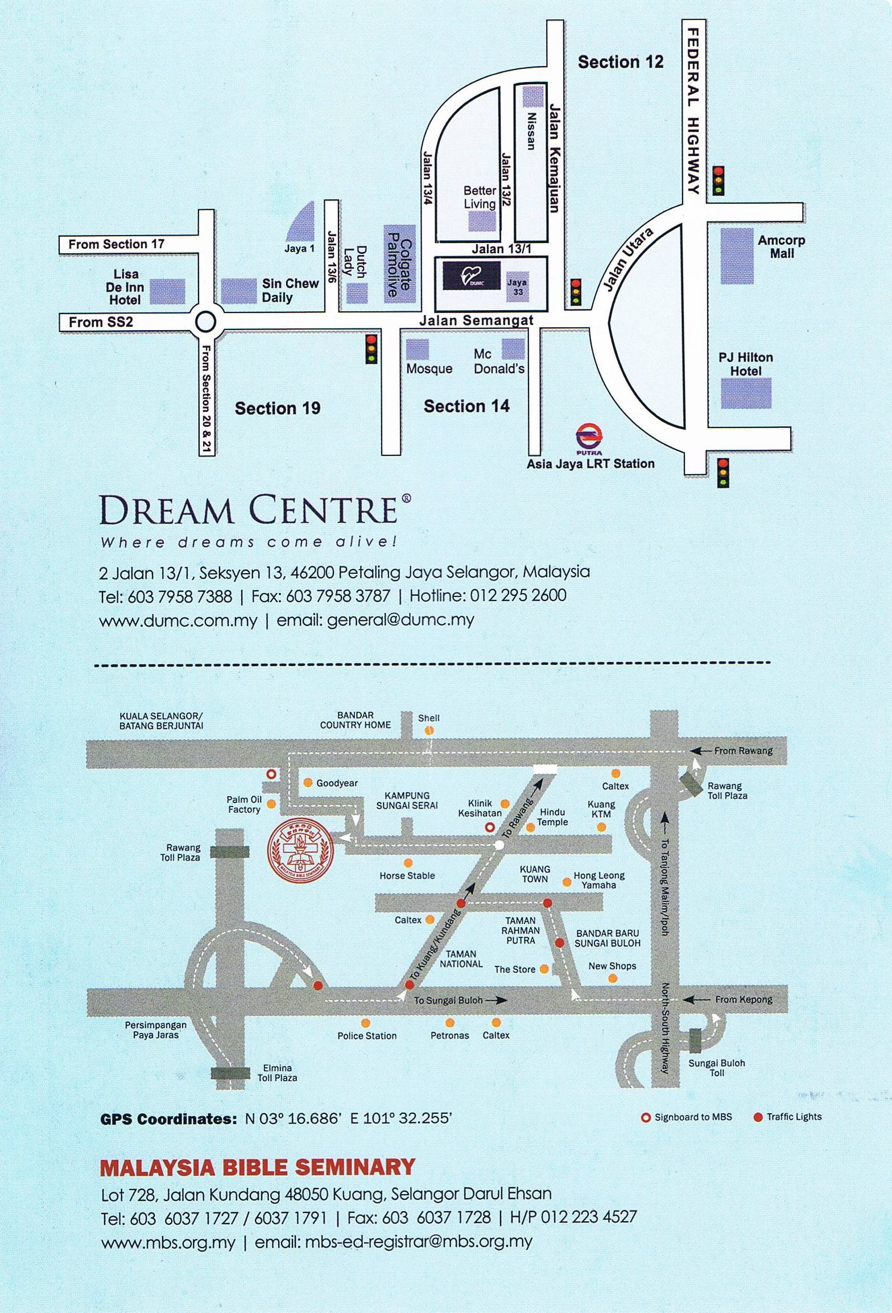

English Department



MALAYSIA BIBLE SEMINARY

OLD TESTAMENT INTRODUCTION 1

16 – 20 MARCH 2015

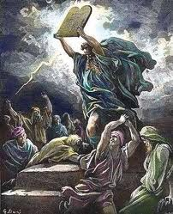

LECTURER : REV DR RICK GRIFFITH

TIME : 9.00AM – 5.OOPM

VENUE : DUMC

