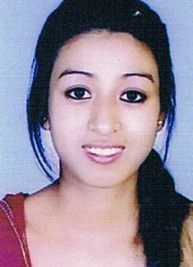
Rekha Lingam Limbu
(Bachelor of Theology)

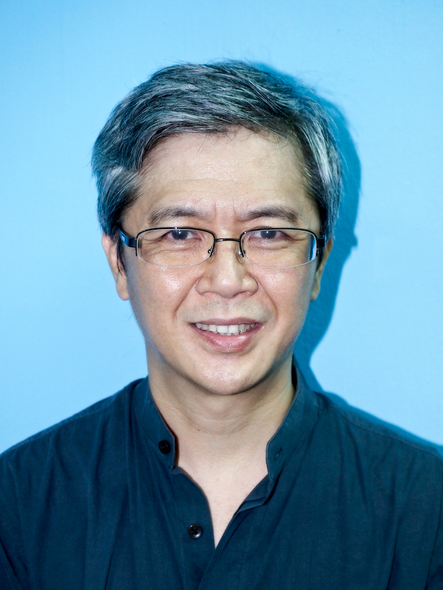
Khen Lim
(Master of Divinity)

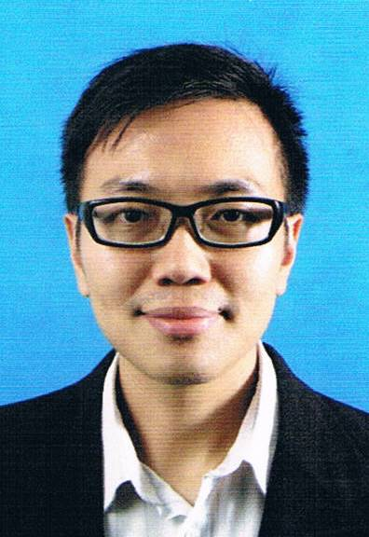
Alex Tan Eng Wai
(Master of Ministry)

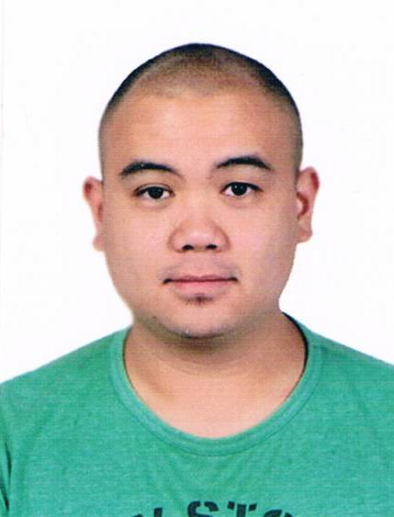
Jeremiah Phua
(Bachelor of Theology)

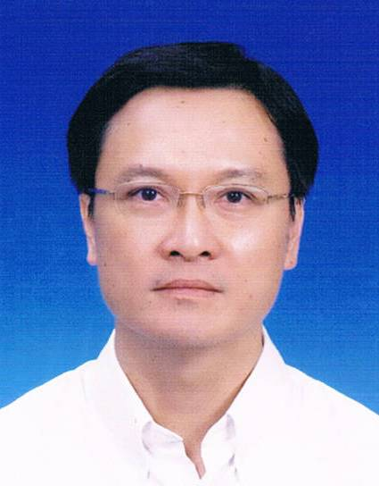
Daniel Hee Ting Wan
(Master of Ministry)

Gilbert
(Master of Christian Studies)

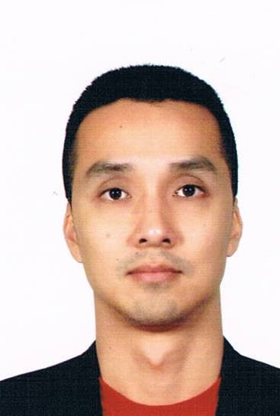
Colin Wong
(Master of Divinity)

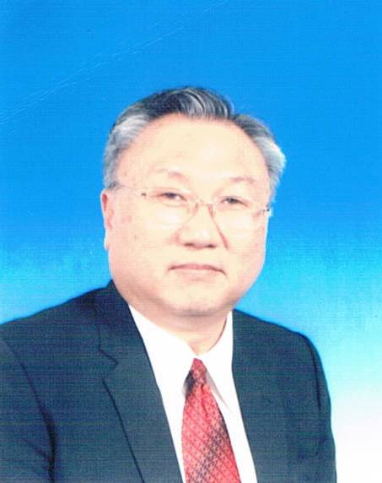
Hong Soon Loong
(Master of Ministry)

Shum Keong
(Master of Divinity)

